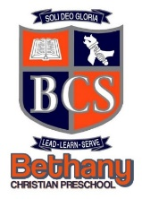BCS Spirit Hoodies/Sweatshirts
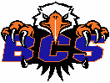
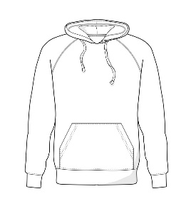
QTY | Item # | Preschool $22: 2T, 3T, 4T | Youth $22: XS, YS, S, M, L, XL | Adult $24: S, M, L, XL-4XL | Total

Item 12 – NORMAL HOODIE NAVY 12A ORANGE 12B (NOTE: XXL + add $2) - PRESCHOOL & YOUTH ONLY IN NAVY

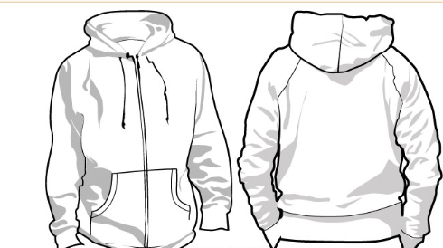
QTY | Item # | Preschool $27: 2T, 3T, 4T | Youth $27: XS, YS, S, M, L, XL | Adult $29: S, M, L, XL-5X | Total
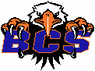

Item 13 – ZIPPERED HOODIE NAVY 13A ORANGE 13B (NOTE: XXL + add $2) – PRESCHOOL & YOUTH ONLY IN NAVY

QTY | Item # | Youth $17: XS, YS, S, M, L, XL | Adult $19: S, M, L, XL-4XL | Total
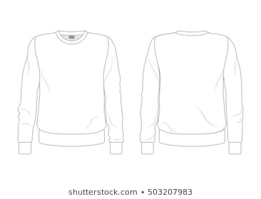

Item 14 – REGULAR SWEATSHIRT NAVY 14A ORANGE 14B (NOTE: XXL + add $2) Total $_________
Date:________ Student’s Name:__________________________________ Teacher:____________________Grade:_______

