

PRESCHOOL UNIFORM ORDER FORM 2018-19

We are offering short and long sleeve t shirts, zipper sweatshirts and hoodies, Please return the order form with cash or check made payable to BCS. The shirts normally are delivered no more than 2 weeks after ordering. NOTE the main design will be on the BACK of the zipper sweatshirts. **NOTE SEE SIZE CHART BELOW NO RETURNS**

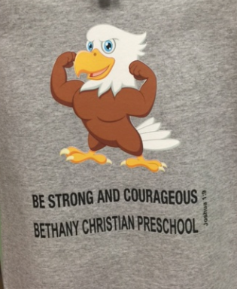

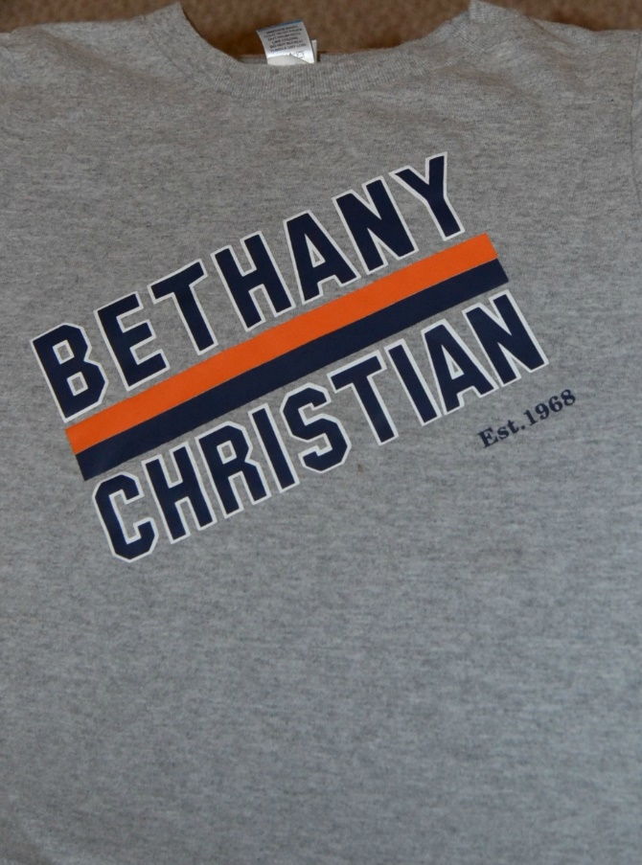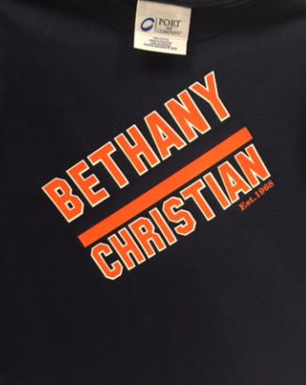

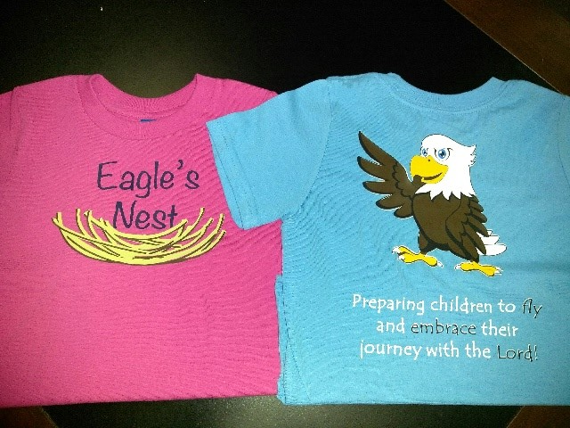

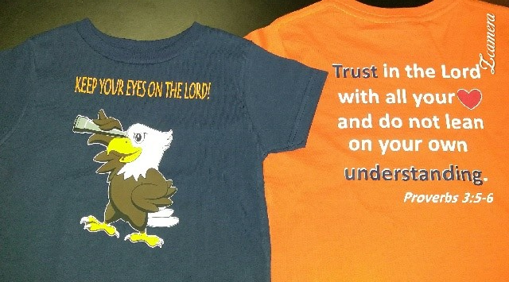

**AVAILABLE SIZES**  2T 3T 4T 5T XS (2-4) S( 6-8)  **\*Please note the 3T and under run small. ONE SHIRT PER LINE PLEASE more space on other side**

|  |  |  |  |  |  |  |
| --- | --- | --- | --- | --- | --- | --- |
| **Student Name** | **Check ONE ONLY** | **Style #** | **Size** | **Quantity** | **Cost** | **Total Cost** |
|  | **LS Navy Tshirt____ (style 1, 2 or 3)**  **LS Orange Tshirt_______ (style 3)**  **Zippered Orange Sweatshirt ____(style 1, 3)**  **Zippered Navy Sweatshirt (style 1, 3)**  **Sweatshirt Gray ________ (style 1 or 2)**  **Sweatshirt Pink _______ (style 4)**  **Sweatshirt Navy--------------(style 1,3,4)** |  |  | **1 PER LINE PLEASE** | **SS T shirt $11.50**  **LS Tshirt $13.50**  **Zippered Sweatshirt $25.50**  **Sweatshirt $15.50** |  |
|  | **LS Navy Tshirt____ (style 1, 2 or 3)**  **LS Orange Tshirt_______ (style 3)**  **Zippered Orange Sweatshirt ____(style 1, 3)**  **Zippered Navy Sweatshirt (style 1, 3)**  **Sweatshirt Gray ________ (style 1 or 2)**  **Sweatshirt Pink _______ (style 4)**  **Sweatshirt Navy--------------(style 1,3,4)** |  |  | **1 PER LINE PLEASE** | **SS T shirt $11.50**  **LS Tshirt $13.50**  **Zippered Sweatshirt $25.50**  **Sweatshirt $15.50** |  |
|  | **LS Navy Tshirt____ (style 1, 2 or 3)**  **LS Orange Tshirt_______ (style 3)**  **Zippered Orange Sweatshirt ____(style 1, 3)**  **Zippered Navy Sweatshirt (style 1, 3)**  **Sweatshirt Gray ________ (style 1 or 2)**  **Sweatshirt Pink _______ (style 4)**  **Sweatshirt Navy--------------(style 1,3,4)** |  |  | **1 PER LINE PLEASE** | **SS T shirt $11.50**  **LS Tshirt $13.50**  **Zippered Sweatshirt $25.50**  **Sweatshirt $15.50** |  |

**Total Due $ ___________________**

Order Date ________________________

Payment sent to Main ________________

Received Date_______________________

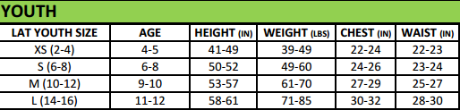

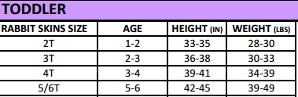

**STYLE 1 (GRAY OR NAVY) STYLE 2 (GRAY or NAVY ONLY) STYLE 3 (ORANGE OR NAVY) STYLE 4 (PINK OR AQUA BLUE only)**