SPIRIT/PE WEAR
Qty | Item # | Sizes |  |  | Line Total
 |  | Toddler: 2T – 5T  (cotton only) | Youth: XS - XL | Adult: XS – 4XL  XXL+ (Add $2)
 |  | Cotton Shirt: $13
 |  | Dri-Fit: $15 |  |  | Sub Total
PE |  | Shirts: $15.00 Shorts: $13.00
 | Shirts
 | Shorts
MC: spirit wear only Fridays
PS: can be worn daily
 |  |  |  |  | Sub Total
 |  |  | Total Purchase
Student’s Name: Grade: |  |  | Teacher’s Name:
Date: |  |  | Circle One: Cash Check Facts SIS
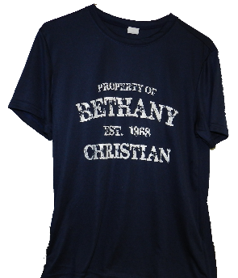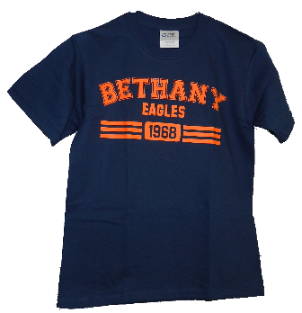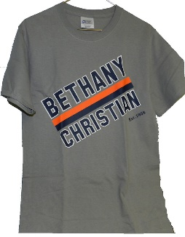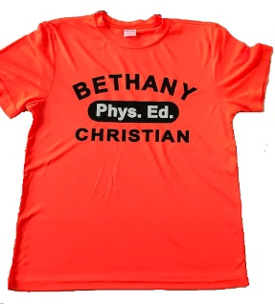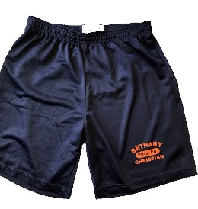
Cotton: 15A 16A 17A PE shirt PE shorts
Dri-Fit 15B 16B 17B

